First go the git working directory, type the command status command to see what’s the status of your git working directory.

# git status

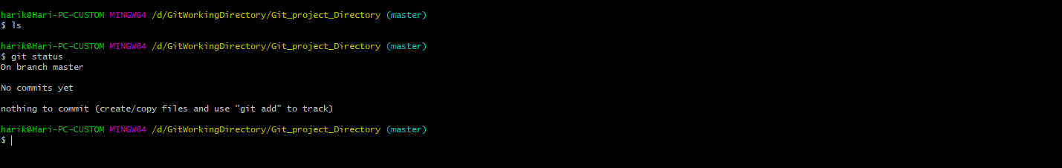

Let’s create some of the dummy files there on that git working directory.

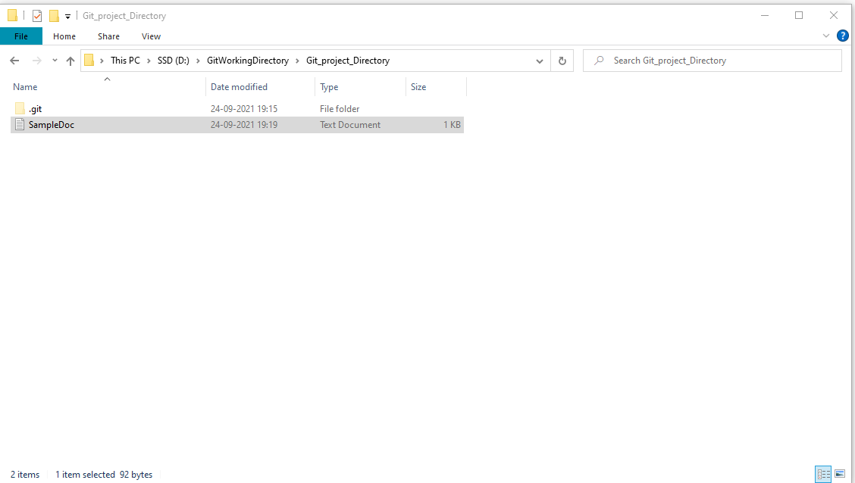

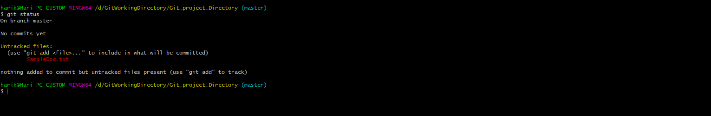

To commit the changes, first I need those files inside my git. To add those files we can use the command “git add <file name> or .”

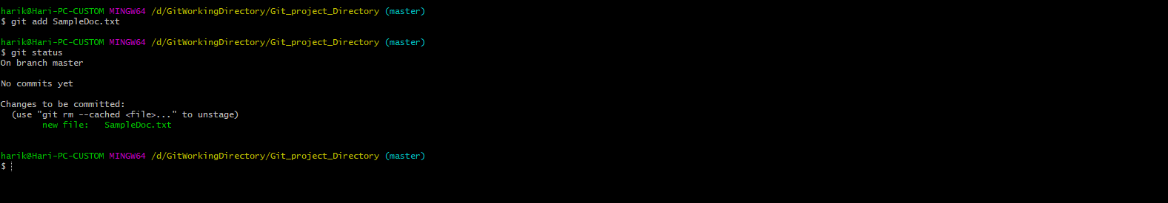

Note: After add the file to git the color became green which means those are ready for commit.

Now you can commit those changes by using command “git commit” as shown below

Option -m for message

# git commit -m “My Initial first commit”

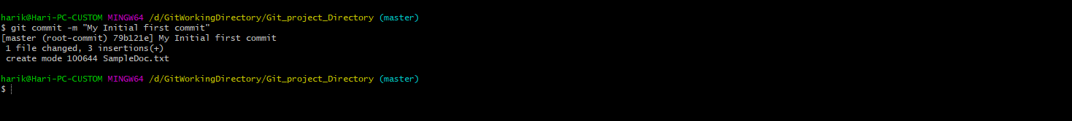



Now I modifying the file by updating/removing some content.

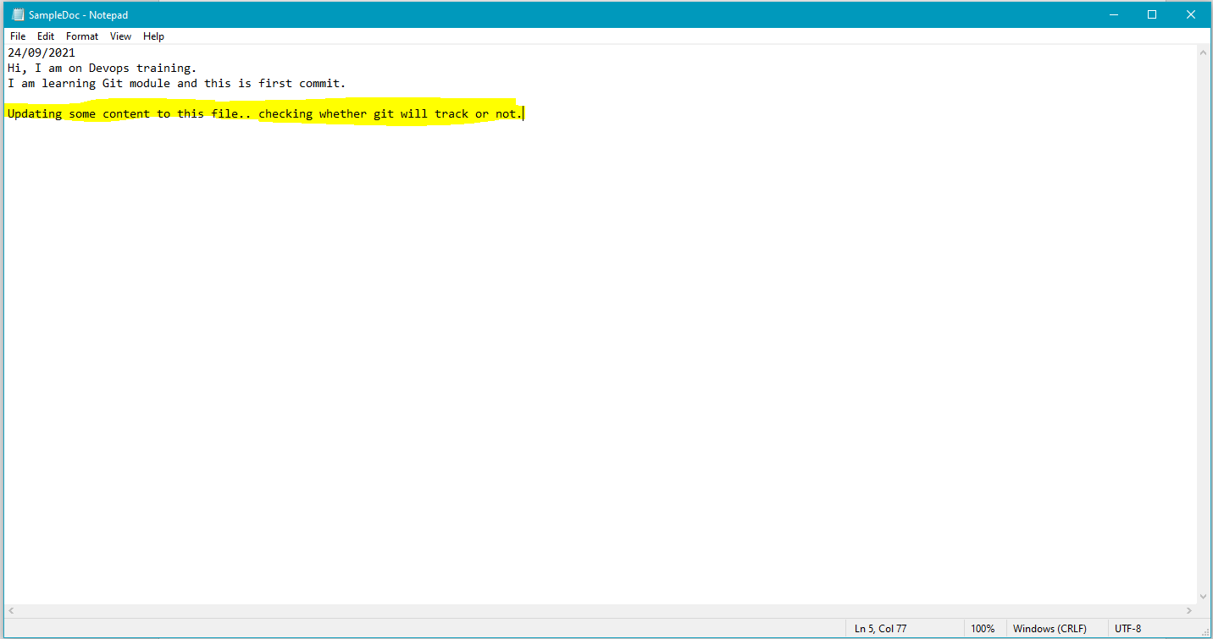

Now you can check the status of the git again, whether it has tracked the modified changes or not.

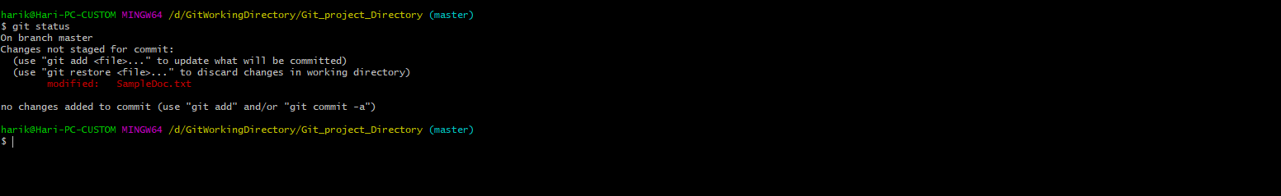

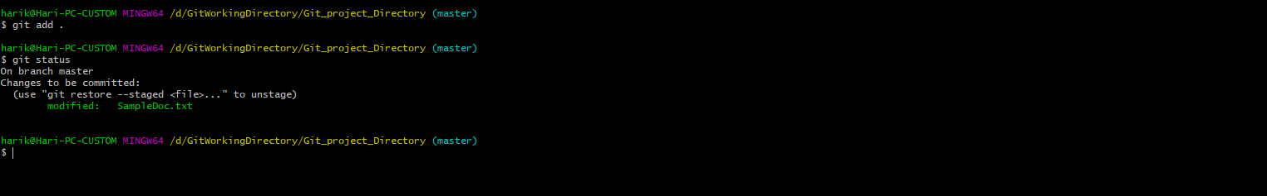

Note: Now after adding the file when type git status, it recognized the file as modified file earlier it was a new file.

Now you can commit the file again by passing the appropriate message by using the option “-m”.

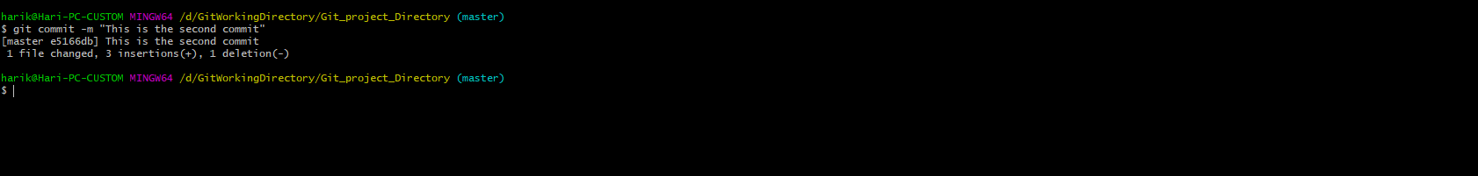

Note: Now for this commit, you can observe git notified us as “1 file changed” but previously when it was a new file it says “1 file Inserted”.

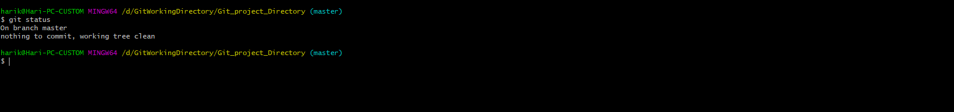

Now you have an option to revert back to previous version also.